Asa Hayes Breyer GEOG-232-502 21 September 2020

**Lab 3: Satellite imagery interpretation with Google Earth**

**Part 1: Simple Measurements with Google Earth. (12 points)**

1. Determine the Length and orientation of the two main runways at Easterwood Airport (6 points)

a. List the coordinates of the ends of each of the runways in Decimal Degrees and Universal Transverse Mercator Coordinates (UTM).

Runway 17/35:

“17 End”: 30°35'47.92"N, 96°21'46.24"W

“35” End: 30°34'39.88"N, 96°21'30.71"W

Runway 11/29:

“11 End”: 30°35'29.26"N, 96°22'22.09"W

“29” End: 30°35'12.86"N, 96°21'26.28"W

b. Measure the length of each of the runways and report the length in feet.

Runway 17/35: 7002.04 ft., Runway 11/29: 5156.35 ft.

c. Determine the heading of each runway. You should consider what direction headings are typically measured from and make sure your answer makes sense.

Each runway has 2 headings, 1 for each possible landing path. Heading is degrees from True North (0deg), rounded to nearest 10 and divided by 10. Numbers on runway indicate bearing to approach from. e.x. 17 is approached from approx. 170deg (South-SouthEast)

Runway 17/35: Path towards End 17 is ~170deg, towards 35 is ~350deg

Runway 11/29: Path towards End 11 is ~110deg, towards 29 is ~290deg

d. Compare your measurements from google earth to official specifications of the runways found online: https://www.globalair.com/airport/apt.runway.aspx?aptcode=CLL. How close were your measurements? The longer runway is labelled as 17/35, and the shorter is 11/29. What do these two numbers that identify the runways come from?

Coordinates were accurate to 10ths of a second, and length measurements were within 3ft of official figures. Numbers on runways indicate both possible headings to approach each runway from.

2. Determine the area of Kyle Field (4 points)

a. Calculate the area of Kyle Field (in square meters and square yards) at 3 different points in time. Record the month and year at the time of each image used to measure the field.

Measurements taken of outside walls, not just playing field itself

2019: 60767.96 m^2, 72677.88 yd^2

2014: 56395.56 m^2, 67405.47 yd^2

1995: 38851.94 m^2, 46466.54 yd^2

b. Is the size of the field really different in all of the images or are there some dates that the field should be the same size, yet the calculated size appears somewhat different in Google Earth? In a few sentences, speculate on this question.

Dates chosen were for current, mid-construction, and earliest available imageries for Kyle Field. As such, there is substantial difference in sizes from the different additions that had or had not been made to Kyle Field by that point. However, more to the point of the question, had the imagery all been from either before or after construction, we would likely notice that the area outlined by the measuring tool would appear slightly off. The likeliest reason for this is differing direction and/or height of the sensor per image, or just the use of different sensors altogether via Google’s addition of multiple overlapping sources.

3. Determine the distance from College Station, Texas, to McMurdo Station, Antarctica (2 points)

a. What is the distance between these two points?

13471.83 km

b. What evidence in the recent images of McMurdo Station can you provide that indicates what U.S. Governmental Agency runs the station?

There is a giant NSF seal a short distance away at approx. 77°50'54.70"S, 166°40'49.00"E

**Part 2: Locate, identify and justify your selection of features in the physical, biological and human landscapes. (18 points)**

A. Physical and Biological Landscape Features

i) Musala, Rila Mtn., Bulgaria [42°10'57.14"N, 23°35'13.26"E]

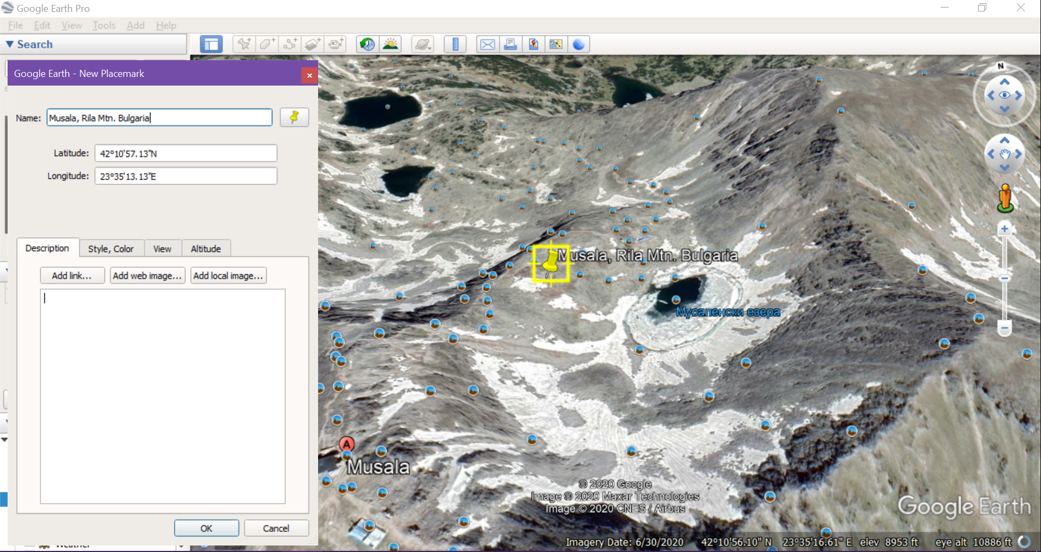

This shows a moraine near the Musala peak of the Rila Mountains in Bulgaria. This viewpoint has been angled to better see the downward “scooped” valley formed by the previous activities of the glacier. Due to the smooth, wide layout and lack of visible streams, this can be identified specifically as a moraine rather than some other type of valley/canyon. Further identifying it past the main moraine structure are the other glacial features along the path, most notably the glacier lakes.

b) Grand Canyon Natl. Park, USA, [36° 6'7.63"N, 112° 6'19.17"W]

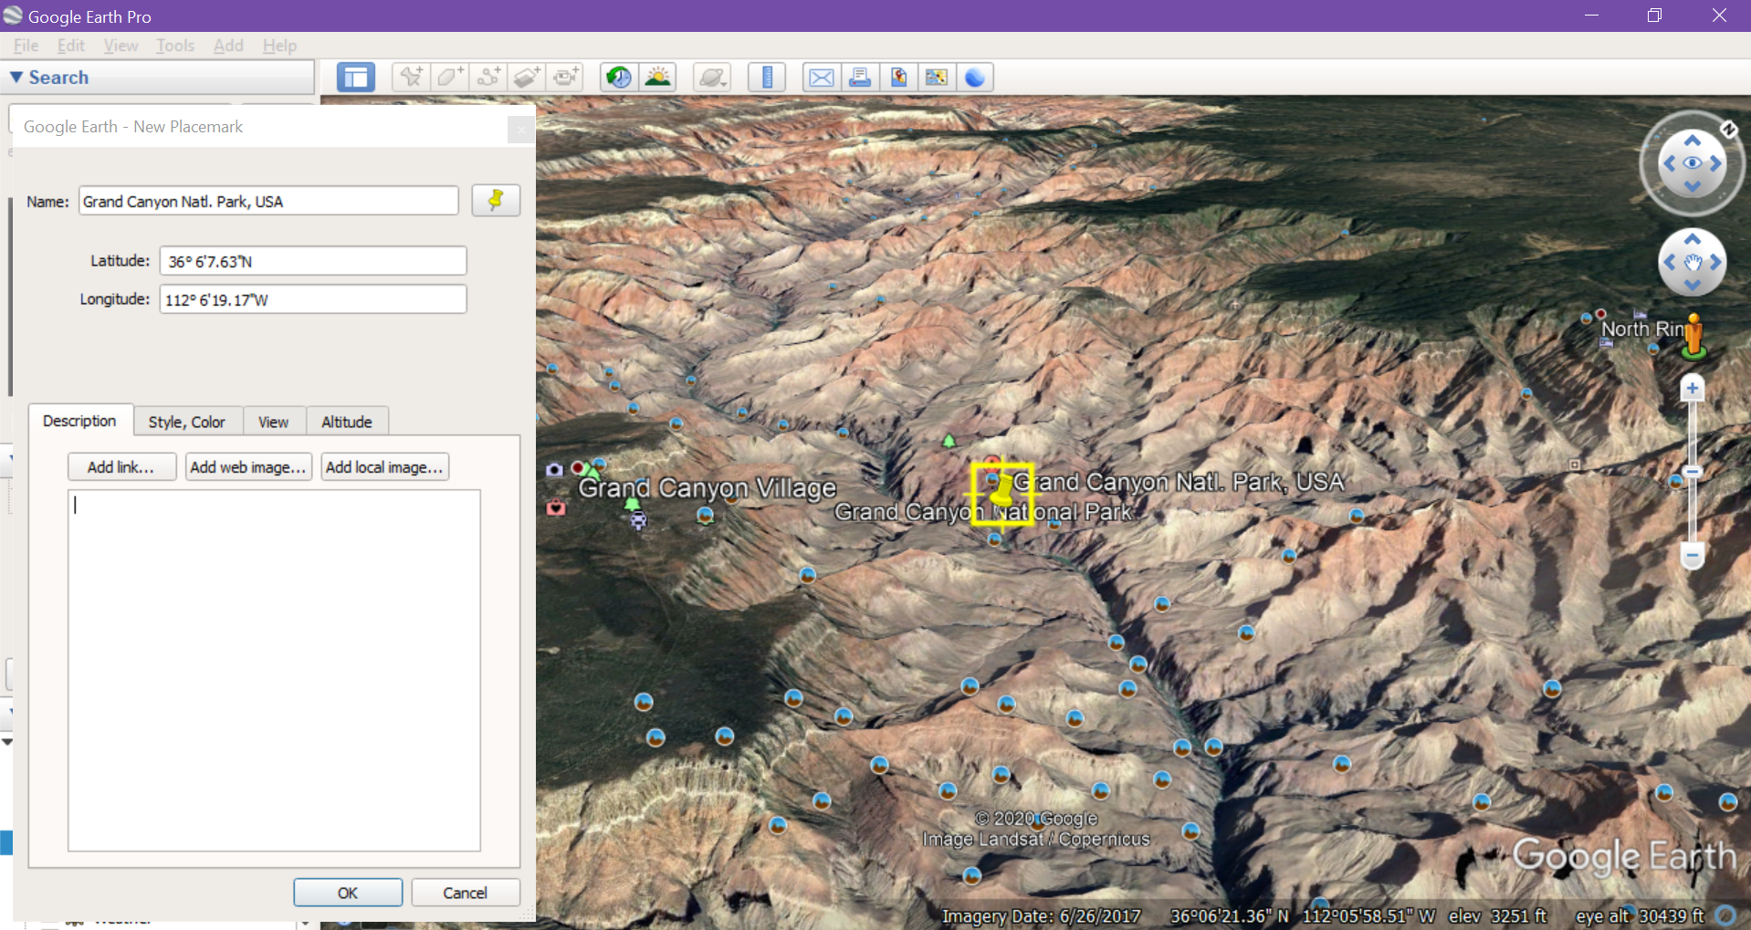

Grand Canyon Natl. Park in Utah is one of the more well-known examples of the capabilities of water to wear away land and create karst landscapes. The image points with the flow of the river at the bottom of the canyon, as can be found from the direction of convergence of all the smaller surrounding canyons. To specify that this is limestone to be eroded as karst, we can see the stratification of the rock as it approaches the bottom. As there is a large network of smaller feeder canyons, we can tell that this area was once home to a large, complex system of streams, rather than the single large river that a single deep gorge would more indicate.

B. Urban Environment

i) Monument/Black Forest, CO [39° 5'17.78"N, 104°48'59.14"W]

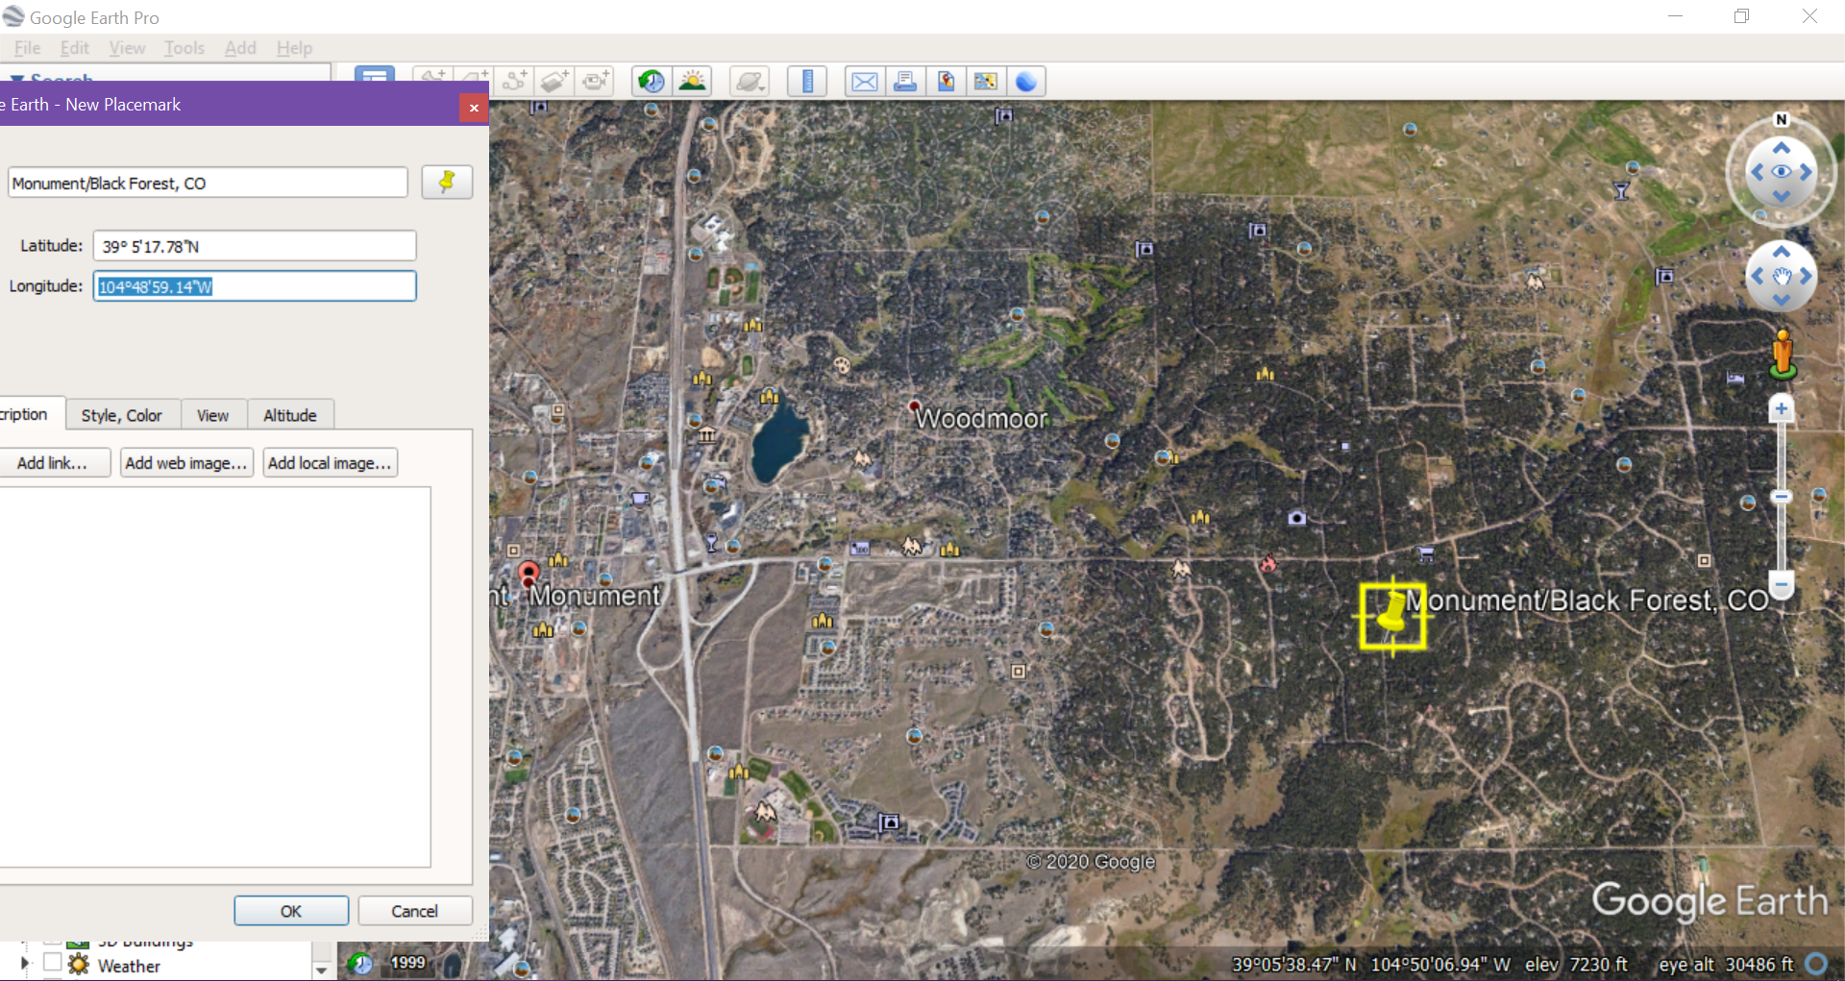

The area shown is a large section of the Monument, CO urban/suburban area. On the right of the image is the main part of the city, which does not extend much further West due to the Rocky Mountains out of frame. Aside from the city center marked with the red pin, almost the entire image is just residential area. This can be seen by the general layout of the roads, as well as the visible structure of the houses as distinct from the commercial buildings near the city proper. This easily showcases low-density sprawl, as the space between houses greatly increases as we move from left to right.

b) University of Algiers, Algiers, Algeria [36°46'14.27"N, 3° 3'16.95"E]

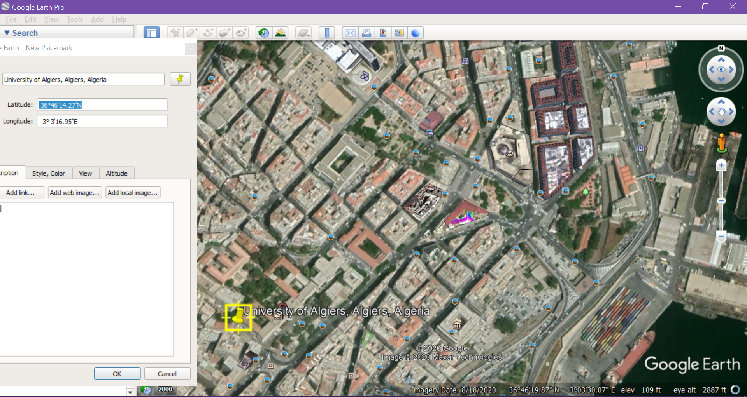

The University of Algiers lies near the Northern edge of the capital of Algeria. In this image, it is immediately different than most surrounding buildings by size, and is not similar in structure to the presumably commercial buildings near the docks at the right end of the image. The wide angle of the image serves to illustrate this difference by showing a greater variety of structures both residential, commercial, and even government buildings nearby. As it both breaks the pattern of the surrounding area and resembles the layouts of other inner-city colleges I have seen elsewhere, the University of Algiers can be identified as such. (4 sentence, use Fig 1)]

C. Human Environment Topics

i) Brazillian Deforestation [12° 8'28.99"S, 53°58'25.02"W]

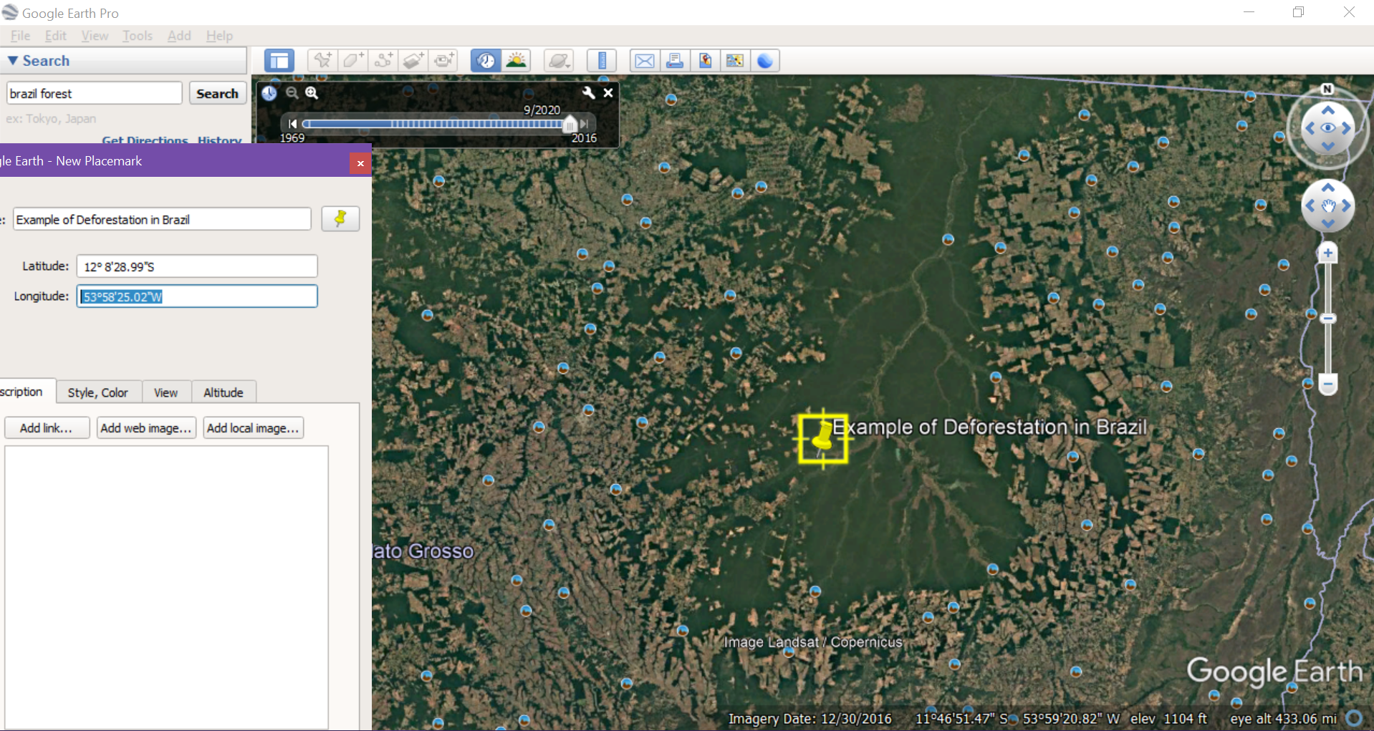 This image depicts encroachment of farmland onto the central forested area of the state of Mato Grosso in Brazil. While the image is at such a small scale to better show the immense area at play, in can be seen at larger scales that all of the angular patches intruding into the area are near-exclusively farmland.

b) [ran out of time]

**Part 3: Locate and describe an interesting geographic location, object or phenomena (10 points)**

i) Ran out of time

**Part 4: Locate and describe an interesting process of landscape change using Google Earth Engine (10 points)**

i) Brazillian Deforestation [12° 8'28.99"S, 53°58'25.02"W]

While I did use this previously, I used the year slider within Google Earth and was shocked by the results. We have been hearing about the intentional, severe deforestation in Brazil via the news for several years now, but the sheer extent is hard to comprehend without actually looking and comparing.